UNIT ONE: THE STUDY OF HISTORY
Define the term history?
- History is the study of the past events.
- A person who studies and writes about history is called a historian.
Types of history
- Political history
- This is the type of history that examines leaders of a community or nation and how they managed that community or nation.
- It studies forms of governments and their growth within local or international bounds.
- It also studies revolutions and how governments evolved
- Examples of the political history are the study of the French Revolution or how the Malawi Kingdom was ruled.
- Social history
- It is about how social groups have developed in the past and how events have shaped people’s day to day life.
- This type of history studies how people relate to each other in various aspects such as religion, music, culture, language and games.
- Economic history
This form of history deals with how people in a community or society earned their living. For example, the Tumbuka-Nkhamanga Kingdom in Northern Malawi developed as a result of trade activities with the East Coast of Africa.
SOURCES OF HISTORY
There are four sources of History which include the following:
- Oral tradition/Remembered History
- Oral traditions are stories that are handed down by word of mouth from generation to generation.
- Oral tradition is also called Remembered History because the past events are presented from memory.
- This source comes in form of folktales, poems, songs, legends, myths, speeches or tape recordings.
Advantages of Oral Traditional Source
- This source of history is useful for events that have no written documents.
Disadvantage of Oral Traditional Source
- It tends to exaggerate or leave out information that recounts their families.
- People may forget what happened or the date of the events
- People may tell lies or add details which may distort history.
- People may be biased for their own reasons
- Archaeology
- Archaeology is the study of buried artefacts and fossils. Examples of artefacts include tools, skeletons, weapons, pottery and bone fragments.
- Archaeological findings can be found in museums and galleries.
- Archaeologists are trained people who study evidence of human existence and settlement. They excavate or dig up ancient human settlements and study the artefacts and fossils.
- Archaeology source of history is also called digging history because it involves archaeologists to dig up ancient human settlements and study the artefacts and fossils.
- Archaeologists find out dates of artefacts and fossils using radio carbon dating method.
- Radio carbon dating method is a process of measuring the amount of carbon released by fossils. The released carbon tells the approximate years the object has been in existence.
- Archaeology is used to study events which have no written records. The period before people learnt to write and read is called Pre- history.
- Therefore, Pre- history was period before people learnt to write and read or the period before written records.
Advantages/importance of archaeology
- It helps you to know and understand about events that are not written down or recorded.
- It gives you evidence of human settlements and socio-economic activities.
- It helps to tell you how ancient human beings looked like.
- It helps to estimate the date of the artefacts and fossils.
Disadvantages of archaeology
- It cannot reveal anything about objects which easily decay such as skins and wooden items.
- Archaeology fails to explain certain aspects of life such as language, religion, dances and music.
- It is expensive as it requires labour to dig and travel to the sites.
- Visual source
- These are sources of history which you can see with your own eyes.
- They are sources of history which take the form of paintings, objects such as pillars and buildings, maps etc.
- The Kachere Tree in Kasungu under which Dr Hastings Kamuzu Banda, the first Malawian head of state, took his early education is a good example.
Advantage of Visual Source
- It presents historical objects in the first hand and original status.
Disadvantage of Visual Source
- The objects are once destroyed; they cannot be replaced. This makes Visual Source to be impossible.
- Written records
- This is history which has been written down in form of books, letters, biographies, autobiographies and newspapers.
- Written records can be found in museums, archives, libraries, record offices and on the internet.
Advantages of written records
- They are the most reliable source of history because they cannot easily be altered or forgotten.
- They are easy to preserve.
- They are more accessible to people. For example, a book placed on internet or libraries can be accessed by anyone in the world.
Classification of written sources
- Primary source
- These are reports made by people who were involved or were actually present and saw the events happening. They are presented in form of letters, diaries, autobiographies and books.
- Secondary source
- They refer to historical information reported by a person who may have heard or read from the primary source. They are also referred to as ‘second hand reports’.
Give reasons why we study history.
- To avoid past mistakes. This means that if you do not study what happened in the past, you are bound to make the same mistakes made by those who lived before you. A Spanish philosopher and essayist George Santayana once said, ‘those who cannot remember the past are condemned to repeat it’.
- To ensure national unity and identity. Common history and culture strengthens a bond of unity in a society. For, example, some Arabic nations are united against Israel because of their common history and culture.
- To plan for future needs of society. It makes the government to predict the number of jobs that would be required at a given period in future. It is also important because if you do not study your social history, you will just be speculating about the future. This is why the Chinese philosopher, Confucius, said, ‘Study the past if you would define the future’.
- To learn from the achievements of others.
- To understand change and how societies became existent.
- To gain useful skills.
- To fulfil the desire to know and understand yourself and the world. An American author of science, Michael Crichton said, ‘If you don’t know history, you don’t know anything. You are a leaf that doesn’t know it is part of the tree.’
TIME CHART
It is a chart that is used to show a marked order of events.
HISTORICAL EVENTS OF MALAWI
Historical event | Year of event
The First Native Association formed | 1912
Chilembwe uprising | 1915
Nyasaland African Congress Formed | 1944
Federation of Rhodesia and Nyasaland | 1953
The return of Dr Hastings Banda | 1958
State of Emergency was declared in Nyasaland by Sir Robert Armitage | 1959
First multiparty General Elections was held in Malawi | 1961
Malawi becomes independent | 1964
Malawi becomes a Republic | 1966
Referendum | 1993
Return to Multiparty politics | 1994
Importance of time charts and dates in history or why is a time chart significant in history?
- Dates help us to know when and how long events have been happening.
- Dates and time chart prevents confusion of events.
- They also show chronology of events.
- They give the reader information of how old an event is.
- They enable the reader to see whether events happened concurrently in different locations.

UNIT TWO: ORIGIN OF PEOPLE
- Mention the English scientist who published his book called The Origin of Species in 1859. Charles Darwin.
- Mention the ape-like creature from which human beings was developed according to Charles Darwin. Hominids
- What name is given to the gradual process by which the ape-like creatures changed to modern human beings? Evolution
- Give the reason why Africa has been called the cradle of mankind or the home of mankind. The earliest known human beings to make and use tools lived in Africa.
- Mention the ape-like creature which was discovered at Rusinga Island on Lake Victoria. Proconsul or the first citizen. It is dated 25 million years ago and is the oldest hominid so far.
- Mention the human-like creature which was discovered at Taung in South Africa in 1925 by Raymond Dart. Australopithecus which means the southern ape. It had a small brain and skull.
- Mention the eastern man or ape-like creature which was discovered in 1959 at Olduvai Gorge in Tanzania by Dr Louis SB Leakey. Zinjanthropus. This had heavy legs and hips with long arms, and awkward hands. It had hairy body.
- Mention the skilled man which was found by Dr Louis Leakey at Olduvai Gorge. Homo Habilis.
- Mention the ape-like creature which was called the up- right man. Homo erectus.
- Mention the ape-like creature who is said to be the Wiseman or modern man. Homo sapien.
STAGES IN THE EVOLUTION OF HUMANS
The cultural evolution is the stage during which homo erectus developed skills necessary for them to adapt to nature and make their environment suitable.
STONE AGE
It was the long period during which human beings used tools made from stone.
The Stone Age has been divided into three stages:
- Early Stone Age or Palaeolithic Age
The following were the discoveries or inventions during Early Stone Age:
- Early started hunting animals, gathering fruits and digging up edible roots for food.
- Early man invented hand-axe- It was used for digging up roots, cutting and skinning animals.
- Middle Stone Age/Mesolithic period
- They made tools from stones and implements such as chisel, knives, scrappers, spearheads and flakes.
- The early man invented the use of fire. They made fire by rubbing two dry sticks vigorously one against the other. Fire was used to roast meat, to keep them warm, to drive away wild animals and clear caves.
- Early learnt the use of traps such as pit trap
- New Stone Age/Neolithic Age
During the period South West Asia. From Asia, the idea of farming spread to North- Eastern Africa along the Nile River Banks
How did settled life contribute to modern civilization?
- Government- It lead to the development of the idea of a dynasty or a line of rulers. This was done to maintain law and order and control trade.
- Religion- The need to answer certain life’s questions such as death etc. led to the emergency of common beliefs about god or gods in order to explain the occurrences.
- Industry- People began to learn new skills like weaving, building granaries etc.
- Trade- It helped them to start barter trade.

UNIT THREE- THE GROWTH OF ANCIENT CIVILIZATION: EGYPT
KING MENES OR NARMER
- He was the first king of Egypt who united Upper Egypt and Lower Egypt into one around 3000BC.
- King Menes acquired the title of pharaoh with his capital at Memphis. Therefore, the capital of the United Egypt was Memphis. Later, the capital was transferred to Thebes in the southern part.
Role of the pharaoh was the chief political and religious leader of Egypt.
Explain the factors that contributed to the growth of Egyptian civilization.
- The Nile River
The Nile River had fertile soils for growing crops. People could irrigate f from the Nile. No wonder the Nile was considered the source of life to Egyptians.
- Safety from attacks
- The Red Sea to the east and the Mediterranean Sea on the northern coast acted as natural barriers. The two seas prevented enemies from attacking Egypt. It was not easy for enemy to cross and invade the country.
- The Sahara Desert in the west offered safety from attacks. One cannot travel for days without water in the desert. Consequently, the country enjoyed stability for many years which encouraged continued development.
- Effective government
- The Pharaohs established a strong system of government which ensured unity among the Egyptians. Stability created by the rule of the pharaoh then encouraged prosperity.
- Good climate
- The area had a temperate climate which was ideal for farming as well as settlement. Crop cultivation was encouraged by good climatic condition of the region.
- Transportation and communication
- The Nile was used for transport and communication. The Egyptians traded with the Middle East and southern kingdoms of Axum and Nubia. The Nile assisted traders to carry trade goods to and from different trade points.
Explain the importance of the Nile River to the ancient Egyptians.
- The Nile River had fertile soils for growing crops. People could irrigate from the Nile. No wonder the Nile was considered the source of life to Egyptians.
- The Nile was used for transport and communication. The Egyptians traded with the Middle East and southern kingdoms of Axum and Nubia. The Nile assisted traders to carry trade goods to and from different trade points

Outline the political hierarchy of ancient Egypt and state the functions of each of the officials.
- Pharaohs
- At the top, there was the king who took the title of Pharaohs. Therefore, Pharaoh was the tittle of the kings of Egypt. They were believed to be gods who represented the chief god.
- Pharaoh means the Great House’ and the Pharaoh was semi-divine.
- The following were the functions of the Pharaohs
- The king was the supreme military commander.
- He maintained law and order
- The Pharaoh was assisted in his role by the nobles and the priests.
- Vizier or prime minister
- The Prime Minister was in charge of administration.
- District governor
- This was in charge of the Nome and assisted in the tax collection and they also kept records.
- The priests
- They acted as medium between the people and the gods.
- They also predicted flood or famine by observing stars and the moon
- They acted as advisors.
Discuss the religious beliefs and practices of ancient Egyptians.
- The Egyptians believed in life after death. This why the pharaohs built huge tombs/pyramids for themselves.
- The Egyptians preserved the dead bodies especially of pharaohs and nobles through embalming so that the dead bodies did not decay. The embalmed corpses are called mummies. The Egyptians preserved dead bodies because they believed in life after death.
- Pharaoh was buried with some of his servants to serve him in the next world.
- The Pharaoh was also buried together with his possessions which he would need in the next life
- The Pharaoh was believed to be the son of the sun god, Re, and the high priests of the religion. The ancient Egyptians practised polytheisms. They worshipped many gods..
Mention the gods and their roles in ancient Egypt.
god | Function
Amen | Father of all gods
Osiris | The good of the next world who judged souls
Isis | Wife of Osiris and goddess of the moon.
Ra or Re | The god of Dawn and Pharaoh’s own god
Thoth | god of wisdom, music and medicine
Anubis | god who destroyed the wicked
Bast | goddess of love and fertility.
Amun | god of capital, Thebes.
Discuss the contributions of ancient Egyptians to modern world.
- Calendar
The Egyptians developed a lunar calendar based on the moon
- Irrigation
The Egyptians invented shaduf, a technician of drawing water from the river Nile into ditches to irrigate crops. They also built canals for irrigation.
- Writing
The Egyptians invented the type of writing knowns hieroglyphs which was used for keeping records of the gifts offered to the gods.
- The Rosetta Stone
Rosetta Stone
- The Rosetta Stone was found by French soldiers near Rosetta in the Nile Delta in 1799.
- The Rosetta Stone contained three types of writings which included the Hieroglyphics, Demotic and Greek.
- The Rosetta Stone was translated by Jean-Francois Champollion in 1822. He translated Hieroglyphics by comparing it with knowledge of Greek.
- The translation of Rosetta stone enabled the beginning of Egyptology or the study of the ancient history, culture and language.
- Architecture
The Egyptians built the burial tombs of dead Egyptians kings- The Pyramids.
The biggest pyramid built in Egypt was the Pyramid of Pharaoh Khufu which built at Gizeh.
Another important pyramid was the Sphinx which was of the Pharaoh Khafre. It represents a creature with a human head and the body of a lion.
- Medicine
The Egyptians developed geometry and also contributed to the knowledge of algebra in that they even worked out a fraction of an inch.
- Astronomy
They developed the knowledge of astrology in order to predict events such as the rise and fall of the levels of water in the Nile River.
Discuss the factors that led to the decline or fall of ancient Egypt or Egyptian civilization.
- Weak rulers
There weaknesses of the pharaohs which led to quarrels and disorder. This
made easy for enemies to invade the country.
- Construction of pyramids
Construction of pyramid by the pharaohs was quite expensive and it used up the state treasury. This made the kingdom weak as most resources had been used for the building of pyramids.
- Military inferiority
- The Egyptians were attacked and conquered because their enemies used more superior weapons.
- The Hyksos conquered the Egyptians because they used horses, chariots and bronze weapons. The Hyksos ruled Egypt for the next 250 years until the Egyptians drove them out of their land in 1750BC.
- The Assyrians also invaded the Egyptians and conquered thembecause the Assyrians used iron weapons which were superior to the Egyptians. However, the Egyptians learnt the use of Iron weapons from the Assyrians.
- Rebellion
Egypt was conquered by Nubia or Kush from the South. This weakened the kingdom further.
- Foreign invasions
- In 332BC, Alexander the Great invaded and made Egypt part of the Greek Empire. He made Alexandria the new capital of Egypt. After his death in 323BC his general, Ptolemy Sorter made himself the Pharoah.
- Finally, Roman Emperor Octavian led the Romans to conquer Egypt in 30BC and making it officially part of the Roman Empire.

UNIT FOUR: THE GREEK CIVILIZATION
- Mention two civilizations that influenced ancient Greece.
Egyptian and Mesopotamian civilizations.
- Which island on the Mediterranean Sea became the centre of early civilization through its trade contact with Egypt and coastal Europe? Crete
- Mention two groups that invaded and formed the Greek city states.
The two nomadic groups who entered gin about 1500bc and invaded Greece were the Achaeans and the Dorians. They defeated the inhabitants of Greece, the Mycenaean people. The Mycenaeans fled and settled in the mountainous western coast of Asia Minor and the nearly islands called themselves the Ionians.
Why did the Mycenaean people call themselves Hellenes?
This was because they all believed that they were descendants of a single ancestor known as Hellene.
NB: Their land was originally called Hella. It was the Romans who called them Greeks.
Explain the reasons why cities developed by Greeks were described as city-states?
It was because they were independent of each other. Each polis or city had its own government and made its own laws. Every city had its own god with its local religious festivals.
Explain five things which the Greeks had in common.
- Greek language- All the Greeks had the same language, Greek.
- Greek alphabet – The Greeks had the same alphabet for their writing which had 22-letter alphabet.
- Greek religion- Both Spartans and Athenians worshipped the same gods.
- Literature and theatre- The Greeks shared same literature. They were all interested in writing poems and telling stories.
In history of theatre, the Greeks were the first to write plays and perform them in theatre. They held competitions and festivals each year to encourage playwrights.
The festivals were held in honour of Dionysus, the wine god.
- Sports
Every four years, all the Greeks met at Olympia to worship Zeus. At Olympia, the Greeks were holding games in the honour of Zeus.
Examples of the games held by the Greeks at Olympia included discuss throwing, running, boxing and chariot racing. Only free-born Greeks competed and had to undergo special training in their own cities.
- Common ancestry- All the Greeks believed that they had one common ancestor, Hellene. Thus they were known as Hellenes.
Mention the areas in which the Spartans and Athenians were similar. Or Discuss the similarities between Sparta and Athens.
- Greek language- They both spoke the same language, Greek.
- Greek alphabet – They both used the same alphabet for their writing which had 22-letter alphabet.
- Greek religion- Both Spartans and Athenians worshipped the same gods.
- Literature and theatre- They both shared same literature. They were all interested in writing poems and telling stories.
In history of theatre, the Greeks were the first to write plays and perform them in theatre. They held competitions and festivals each year to encourage playwrights.
The festivals were held in honour of Dionysus, the wine god.
- Sports
Both of them as the Greeks met at Olympia to worship Zeus. At Olympia, the Greeks were holding games in the honour of Zeus.
Examples of the games held by the Greeks at Olympia included discuss throwing, running, boxing and chariot racing. Only free-born Greeks competed and had to undergo special training in their own cities.
- Common ancestry- Both believed that they had one common ancestor, Hellene. Thus they were known as Hellenes.
Discuss the differences between Sparta and Athens.
- Governance
Sparta was a military state ruled by two kings whose duty was to direct military affairs. Each of the two kings checked the other’s action so that no one became too ambitious. In Sparta there was also an Assembly of Citizens to which all males over thirty years and above were members. The main function of the Assembly of Citizens was to approve decisions taken by the government.
On the other hand, Athens was a democracy in which all male citizens, except slaves, took part in the Assembly. The Assembly discussed the day-to-day affairs of government. The idea of the Assembly was begun by Solon.
- Education
The Spartans emphasized the training of the body and the boys learnt mostly the laws of the state and very little academic work. Spartan girls received physical education designed to make them strong mothers of healthy babies who could become soldiers.
In Athens, boys from the age of six went to schools. Children of the rich were accompanied or escorted to school by a special slave Pedagogus who carried their books to school.
The two main aims of education in Athens included the following
- To develop a person’s mental and physical powers and to be able to express their thoughts clearly.
- It prepared them to be good citizens who could participate in the government of the city-state.
The subjects taught in schools included poetry and literature, philosophy, mathematics and astronomy, music and dancing and gymnastics.
- Way of life
To prevent a slave uprising, the Spartans created a strong military state. From the age of seven, Spartan boys lived in barracks where they were trained to use weapons, develop courage and endurance. Little time was spent on reading or writing. At the age of 18 they joined men’s barracks as soldiers. They were not allowed to marry until they had fought in a war or went out on raids. They only lived at home after the age of 30. Girls were expected to be athletic and tough in order to bear a child who would be a soldier.
Athens was generally a busy trade city –state. Athenians traded in wine and olives with other islands and territories around the Mediterranean Sea. This made Athens wealthy. They also made pottery and sculpture.
Discuss the reasons why the Greeks never formed an empire. Or Discuss the reasons why ancient Greece never formed an empire.
It was because Greece was mountainous country with swift and short rivers which made travel and communication between the settlements difficult. In other words, it was due to its geography and rivalries. This made Greeks not to belong to a single nation.
Discuss the religious beliefs of ancient Greeks.
- The ancient Greeks believed in many gods and goddesses They worshipped the same gods and goddesses.
- The Greeks believed that all their gods and goddesses lived on Mount Olympus.
Identify the Greek gods and goddesses, and state the roles of each of the gods and goddesses against their names.
GODS/GODDESSES | ROLES OF THE GODS/GODDESSES
Zeus | the father of all gods and lord of the weather
Hera | wife of Zeus and goddess of marriage
Aphrodite | goddess of love and beauty
Poseidon | god of the sea who caused storms when angry
Dionysus | god of wine
Apollo | god of light and music and his temple was at Delphi
Athena | goddess of wisdom and peace
Ares | god of war
Artemis | goddess of moon and hunting
Hermes | messenger of the gods and ruler of the winds
State the contributions of ancient Greeks to the world.
- Sports
The Greeks introduced Olympic games that the modern world has borrowed.
- Literature- The Greeks were the first poets and playwrights. The Greeks were the first to write and perform plays that the modern world has borrowed. The Greeks wrote tragedies and comedies. They held yearly festivals at which best playwrights and actors were rewarded. This was held at the time of wine harvest in honour of Dionysus.
- History- The Greeks wrote the early history of Greece
- Philosophy- Ancient Greece produced the most important great thinkers who tried to discover the meaning of virtues.
- Science and mathematics- The Greeks studied science and mathematics. They also studied medicine, diseases and geometry. In astronomy they discovered that the earth is round and that planets move around the sun.
- Politics – Greece produced some great statesmen such as Solon, Pericles and Alexander the Great. Their ideas have contributed a lot to governance and culture in the modern world.
Why are the following remembered today?
- Homer
He was the greatest Greek poet and wrote two famous poems Iliad and Odyssey.Iliad tells the story of the early Greek wars with the Troy and Trojan.Odyssey tells about the return of Odyssey from the war with the Troy.
- Aristophanes
He wrote the comedy known as ‘Wasps’ which was full of obscenity and laughter
- Sophocles
He wrote plays which included Ant gore and Oedipus Rex. He was the first to write tragedies.
- Herodotus
He was the father of history and wrote the earliest history book called Histories. This is the book about the Greek war with Persians and how Greece fell under the Persians.
- Thucydides
He is remembered for his book called History of the Peloponnesian wars. These were Greek wars involving specifically Athens and Sparta.
- Socrates
He was a stone mason and Greatest Greek thinker who taught his pupils about goddesses, truth, beauty and justice. He taught the youth by asking questions which led them to discover that they did not know as they thought they did.
He became very popular and the trained teachers known as Sophists grew jealousy of Socrates. He was sentenced to death by taking a cup of hemlock because the Sophists falsely accused him of teaching young people to disrespect gods.
- Plato
He was the pupil of Socrates. He wrote a book called The Republic in which he described what a good state should.
The Plato’s student who became a famous philosopher was Aristotle.
- Aristotle - He was the famous philosopher who wrote the book called Politics.
- Pythagoras
He formulated the Pythagoras theorem which states that in the right angled triangle, the square of the hypotenuse is equal to the sum of the square of on the other two sides.
He also founded Pythagoreanism- a movement with a mixture of political, religion and philosophical ideas.
Pythagoreans were the first to suggest that the earth was round and that it moved around the sun.
- Archimedes
- He introduced the principles of levers and pulley system. He formulated the value of pi and worked out specific gravity.
- Thales
- He concluded that all things are made from water which is the main substance.
- Democritus
- He was the first person to conclude that everything is made from small particles called atoms.
- Solon
- He is remembered for his political reforms. He encouraged the participation of all male citizens in Athens in law-making process. His idea led to the beginning of democracy.
- He introduced a written code of law in Athens.
- Pericles
- He is believed to have said, ‘we believe a man should be concerned about public as well as private affairs, for we regard the person who takes part in politics not as uninterested but as useless.’
- He repaired the defences of Athens and engaged famous architects and sculptors who rebuilt the temples on the Acropolis on which the Parthenon or the temple of goddess Athena was.
- Alexander the Great
- He was son of King Phillip of Macedonia who invaded Greece in 338BC. After his father died, Alexander took over at the age of twenty.
- When the Greek states rebelled, Alexander put down the rebellion and completely destroyed the city of Thebes, except for the house of a famous poet Pindar to show his respect for the Greek culture.
Discuss the achievements of Alexander the Great.
- Alexander the Great conquered the Persian army at the battle of Granicus. He again defeated the Persian army under king Darius III at the battle of Issus in 333BC.
- Alexander the Great defeated Egypt and made the town of Alexandria as the new capital. Hence he established many cities including Alexandria which had a university, a temple, theatres, gymnasia and a market square.
- He spread Greek civilization throughout the empire he created.
- He made the Greeks and Macedonians settled in different parts of the empire.
- He introduced Greek language throughout the empire. Greek was the language of trade, education and literature throughout the Mediterranean and the Near East.

UNIT FIVE: THE AZTEC EMPIRE
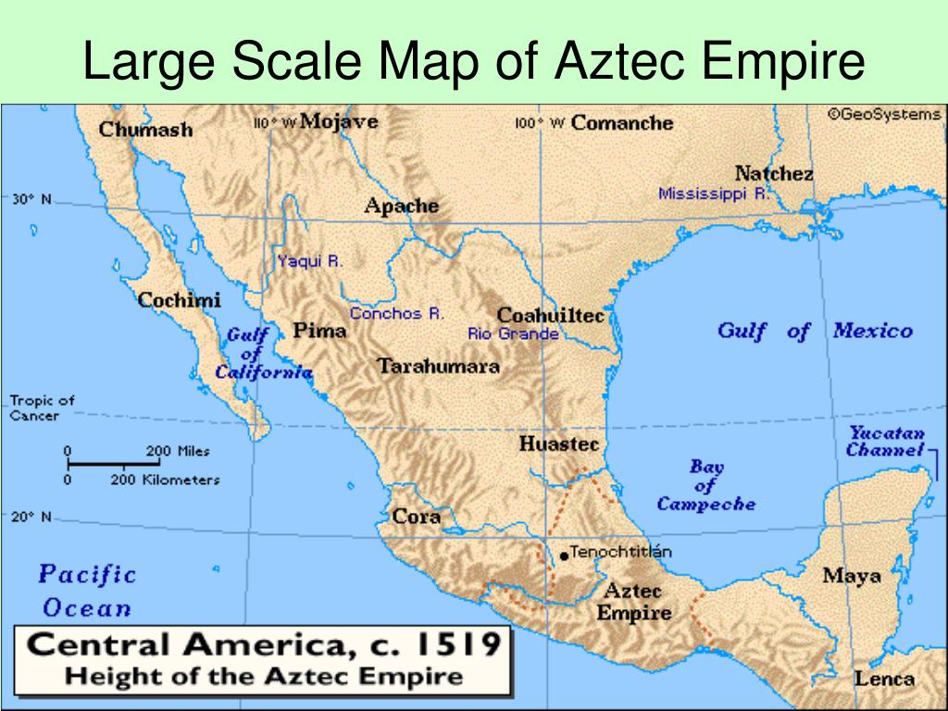
Explain the origins of the Aztec Empire.
The Aztec Empire was founded by a group of nomads called the Mexica who migrated from a place known as Aztlan in the north beginning around 1200AD. They were promised by their warrior god Huitzilopochtli to establish a great civilization in a marshy area. They built their capital called Tenochtitlan. The Mexican found other three groups who had already settled in the area. These three groups of people were the Tepanecs, the Acolhuas and the Culhuas. These always shunned the Mexican as snake-eating barbarians. Among these three groups of tribes, the most powerful tribe was the Tepanecs of the city of Azcapotzalco to whom the Mexican paid tribute. The Mexica also served as mercenaries or hired soldiers for the Tepanecs.
Discuss the factors that led to the growth of the Aztec Empire.
- Triple Alliance
The Mexicans led by their king Itzcoat, formed an alliance with the city-states of Texcoco and Tracopan and defeated the Tepanecs in 1428. The victory of these three states marked the beginning of the Aztec Empire.
The Tripple alliance went on and conquered several other states. In time, Tenochtitlan came to dominate the alliance. The Mexicans emerged as the rulers while Texcoco and Tlacopan were under their control.
- Military prowess
The Mexicans fought the surrounding peoples and took them as prisoners sacrifice to their sun god. The king rewarded the warriors who brought many slaves.
The conquered city-states supplied the Aztec with gold, copper, feathers, incense and cocoa beans.
- Religion
Religion was connected to warfare and human sacrifice. Battles were fought just to obtain captives for sacrifices. In the process, they forced the defeated city-states to pay tribute. With more and more conquests, the Aztec expanded and grew rich.
- Environment
The Aztec capital was well-located. It had fertile soils and plenty of water for irrigation. The area had lakes, canals, and other waterways which made transportation easy. They used dug out canoes to transport goods to various places in the empire.
Mention two groups with which the Mexicans formed an Alliance against the Tepanecs.
The Mexicans led by their king Itzcoat, formed an alliance with the city-states of Texcoco and Tracopan and defeated the Tepanecs in 1428.
Discuss the religious beliefs of the Aztec Empire.
- The Aztec believes in many gods.
- The Mexican believed in life after death.
Identify the different gods and the roles they played in the Aztec Empire.
gods | Roles they played
Huitzlopochtli | The warrior god sun
Centeotl | God of the corn
Tlaloc | God of rain, water and fertility
Xipe totec | God of spring and regrowth.
Tezcatlipoca | All-powerful god
Tottiuh | Sun god
Mictlantecuhli | Ruler of the dead
Quetzalcoatl | God of civilization and learning
Ehecatl | God of wind
Discuss the political organization of the Aztec Empire.
- Each city-state was governed by a City Council.
- Within the council, a four-member Executive was chosen. One of theExecutive members was again chosen as the Tlatcan who acted as the leader of the council.
- The leader of the Council was called the Huey Tlatcan or Great Speaker.
- The Aztec Empire established an authoritarian monarchy.
- The emperor was assisted by priests, judges, governors and other officials.
- The family clan heads formed the Calpulli which was the local government. In the cities, the Calpulli were less-related because there were people of different cultures and races.
- Each Calpulli had officers to keep order. To administer justice, to lead in war and to maintain records. The Calpulli also had a local temple, an armoury, a store house for goods and tribute.
Discuss the factors that led to the decline and fall of the Aztec Empire.
- Sacrifices
The Aztecs were driven into constant warfare in order to obtain captives for sacrifices to the gods. In the end, this reduced the number of farmers, craftsmen and other producers who would have kept the empire strong.
The Aztecs obtained captives for sacrifice from surrounding peoples. Because many of their own people were being sacrificed, these people resented the Aztecs. The city-state of Tlaxcara in the end joined the Spaniards against them for this reason.
In addition, the Spaniards the Spaniards used the horror of human sacrifice which they considered as barbaric and evil to conquer the Mexicas
- Religion
The Aztecs believed that one day the sun god would come in form of a man. He would say that he came over the sea, from the east on the wings of a great white bird.
When the Spaniards under Hernando Cortez arrived, the Aztecs thought they were gods. The Aztecs did not immediately respond to their attack. The Spanish easily defeated the Aztecs.
- Epidemic of smallpox
One of Cortez’s men contracted small pox which quickly spread among the local population. The local people were not immune to the new disease and did not know how to treat it. Within a short period, many people died and the population was greatly reduced. The Spanish conquered the Aztec Empire in 1521 and this led to the fall of the empire.
Discuss the contribution of the Aztec Empire to the modern world.
- Historians still know much about their contribution from archaeology despite the Spaniards destroyed the capital of the Aztec Empire.
- The Aztecs constructed huge temples near Mexico City.
- The Aztecs were good artists. They made fine paintings and were involved in making jewellery, pottery, statutes and carvings.

UNIT SIX: CHINESE CIVILIZATION
Discuss the location of the centre of the Chinese civilization.
The Chinese Civilization developed on the great bend of the Yellow/Huang He River Valley in Northern China around 3000BC.
Discuss the factors that led to the growth of ancient Chinese civilization.
- Rivers
The Yellow River provided them with plenty of water for farming and had fertile soils for the growth of food crops to feed the population. This made early Chinese to grow millet and rice. They also kept cattle, sheep, pigs, dogs and horses.
- Natural barriers
China had many natural barriers which kept the country from external invasions. They included the mountains, deserts and seas.
- The Himalaya Mountains to the south east
- The Taklamakan Desert to the west
- The Yellow Sea to the northeast
- The china sea to the southeast
All these made it difficult for the enemies to attack china. Safety from attacks enabled the development of ancient Chinese civilization.
- Religion
- The ancient Chinese believed in many gods. They worshipped a natural force called t’ien or Heaven who ruled over all the other gods. It was believed that Heaven decided who would be the ruler.
- The Emperor or Empress believed they had the Mandate of Heaven to rule as long as they ruled well. If their rule was bad, they lost the mandate of Heaven. The result is that they would be overthrown and be replaced by someone else. This encouraged good governance.
- Ancient philosophies
- Chinese philosophy encouraged stability and governance. The most outstanding ancient philosophies were Confucianism and Taoism.
- Confucianism became the philosophy of the ancient Chinese governments. Government was dominated by a highly trained and dedicated civil service.
- Confucianism
- The founder of Confucianism was Kung-fu-tse popularly known as Confucius who lived during the Zhou Dynasty.
- Confucius taught that rulers are expected to lead by example while subjects are to be respectful and obedient. He stressed three things: virtue, good governance and merit based promotion for government offices. Consequently, Chinese emperors established government promoted or hired officials based on merit.
- The teachings of Confucius were collected by his pupils in a book, The Analects. This philosophy encouraged good governance and respect for authority in his teaching.
- Taoism
Taoism believes in Wu-wei or non-action which means do not force your way to get things done. Rather, allow things to happen as they do. It also teaches humility and compassion.
- Legalism
Legalism believes that people are naturally evil. Consequently, they deserve strict laws and harsh punishments in order to create order and peace.
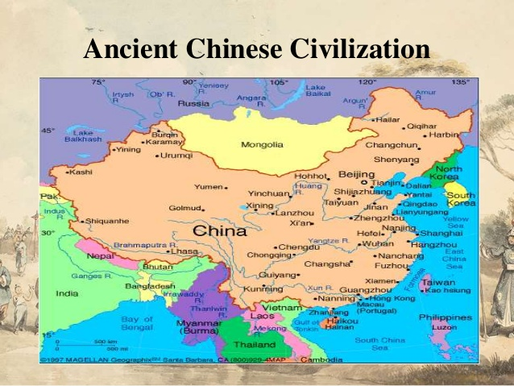
Discuss the political organisation of the Chinese civilization.
- The ancient Chinese had a highly developed political hierarchy. In its early stages, the king was assisted by nobles. Below the nobles were the commoners and finally slaves.
- Later, the Chinese developed a highly centralised government. The emperor was at the centre of the political system. Below the Emperor was the Grand Council which consisted of government officials. It was the most powerful body.
- The country was divided into provinces. Each of the provinces was under a Governor. Every two provinces were headed by a Governor- General.
- The government relied on the army and labour force. Labour was required for projects such as irrigation and wall for defence.
Explain the contributions of each of the following dynasties in ancient Chinese civilization.
- Shang Dynasty (1570-1045BC)
- They found their kingdom in the Huang o River and their kings were referred to as ‘the Son of Heaven’ and Lord of Earth. They built their capital at ANYANG.
- They used bronze weapons and vessels and horse-drawn chariots in warfare.
- They invented writing which was in form of little picture s that represented words.
- They invented the calendar.
- They practised ancestral worship which was the belief that the dead ancestors can intervene in the affairs of the living.
- They captured prisoners of war as slaves for sacrifice to their god.
- Zhou Dynasty (1045-221BC)
- They conquered the Shang in about 1045BC. Their kings were believed to rule by Mandate of Heaven.
- They created a feudal state where they placed some of their land to their followers. In return, they provided the Zhou with chariots and soldiers in time of war.
- They ruled in the period called the Golden Age of ancient China in which slavery was less common.
- It was during their reign when Chinese philosophies such as Confucianism’s, Taoism and Legalism emerged.
- They invented the kites, the umbrella, a horse collar
- They used tea during their reign
- General Sunzi wrote a book called the art of war which was the first military manual.
- Quin Dynasty (221-206BC)
- They united the different Chinese states into one country during their first emperor Shi Huangdi.
- Shi Huangdi abolished local states and set up a strong centralised government.
- They standardized weights and measures, currencies and Chinese writing.
- They banned private ownership of weapons. No individual but the state was allowed to own weapons.
- They imposed heavy taxes in order to support military campaigns and building projects.
- Han Dynasty (202BC-220AD)
- This dynasty was established after the death of Huangdi in 2009BC.
- It conquered more territories in South and West China.
- It established a government based on the teachings of Confucius. This made Confucianism to become the standard for selection into the civil service.
- It established an Imperial Academy where people studied Confucianism
- It developed trade with the West and started exporting silk to the Roman Empire.
- It invented the wheelbarrow and papermaking.
- Sui Dynasty (581-618AD)
- It constructed the Grand Canal between the Yangtze and northern China. The canal eased the problem transportation of grain and other goods to the north from the south.
- Tang Dynasty (618-907AD)
- It led china to prosperity during which many traders and scholars came to the capital at Chang’an.
- It experienced the rising of the poets like Li Bo and Du Fu.
- It adapted Buddhism
- Song Dynasty (960-1279)
- It introduced the system of civil service examination which allowed the selection of officials based on merit and talent other than birth.
- It developed Neo-Confucianism, a new blend of Confucianism that combined elements of Buddhism and Taoism with Confucianism.
- Ne-Confucianism was introduced by the philosopher called Zhu Xi.
- Yuan Dynasty (1279-1368AD)
- It established the skilful hoarse men.
- It was visited by Marco Polo, a traveller and a merchant from Venice.
- Trading activities between China and Europe increased. More silk was being exported.
- Ming Dynasty (1368-1664)
- Their rule was an era of prosperity and stability.
- Qing Dynasty (1644-1912)
- It increased agriculture, trade and handcraft industry.
- The Manchu dynasty came to an end when revolutionaries led by Dr Sun Yat-sen forced six-year-old Emperor Pu Yi to abdicate on 12 February, 1912.
Explain the contributions of the ancient Chinese Civilization to the world.
- Philosophy
- The ancient Chinese philosophy has contributed to a modern thought on governance, education and literature. Confucianism was used to select officials based on talent.
- Defence system
- The Chinese built the Great Wall which still stands today. They also invented the gun and gunpowder which is still important for defence.
- Wheel
- The Chinese made wheel with spokes for the carts which were commonly drawn by water- buffalos.
- Literature
The Chinese produced one of the greatest world’s literature works. The subjects dealt included philosophy, history, religion, science and politics.
The first known Chinese work of literature is a collection of poems called the Classic of Songs.
During the Han era the Chinese wrote histories and dictionaries.
- Silk cloth
The Chinese discovered how to make threads from fibres produced by a kind of caterpillar called silkworm.
- Writing
The Chinese developed a system of picture writing or pictographs. They wrote history, poetry and religion.
- Painting
They invented landscape painting during the Song Dynasty. The most common landscapes were called shanshui or mountain- water which consisted of high mountains and vast stretch of water.
- Use of natural manure
The Chinese were among the first people to use animal dung and human waste to improve soil fertility.
- Standardization of measurements of units
The Chinese introduced same units for all measures, weights and currency to ensure uniformity.
- Large-scale water control projects
The ancient Chinese discovered irrigation techniques. Hence they built large-scale irrigation projects which were capable of water storing and draining. The projects greatly improved agriculture.
- Calendar
The ancient Chinese worked out a three hundred sixty-five and a quarter days’ calendar.
- Pottery
The Chinese invented the art of making items from porcelain which was an activity common in the Yellow River civilization.

UNIT 7: MALI KINGDOM
Explain historical background of Mali kingdom
- The founders of Mali kingdom were the Mandingo people of the Kangaba chiefdom. Kangaba was the vassal state. A country which was controlled by Ghana Kingdom.
- The first capital of Mali kingdom was Jeriba which was later transferred to Niani on the Sankuru River banks.
- Ghana kingdom was conquered by Sumanguru, king of the Sosso around 1224.
- Sumanguru destroyed Kangaba and killed all members of the Keita, the ruling clan, except Sundiata because he was lame and sickly.
- 1n 1235, Sundiata Keita defeated Sumanguru at the battle of Kirina. This marked the beginning of Mali kingdom, from a tiny chiefdom to an empire.
What was the role of Sundiata Keita in the growth of Mali kingdom?
- Sundiata Keita expanded the Mali kingdom through conquests. He conquered the famous towns of Timbuktu, Djenne and Gao in the north. Timbuktu, Jenne and Gao were trading centres of caravan trade.
He also conquered the gold-producing regions of Wangara and Bambuk. Sundiata Keita contributed to the prosperity of the kingdom of Mali by taking control of the gold-producing regions.
- Sundiata Keita helped in the spread of Islam. In 1076 AD Ghana was invaded by Almoravids, a group of Muslim Berbers.
The Almoravids invaded Ghana kingdom in order to convert people to Islam
Through trade contacts with the Muslim Arab traders, the Keita had long embraced Islam. During the reign of Sundiata Keita, Mali was drawn closer to other Muslim states. In fact, it was during his rule that Islam was accepted throughout the empire.
- Sundiata Keita created an effective system of government. He divided the kingdom into provinces each under a trusted governor. The governors were mostly military governors who intended to control the troublesome vassal states. In so doing, Sundiata helped maintain Mali as a united country.

MALI KINGDOM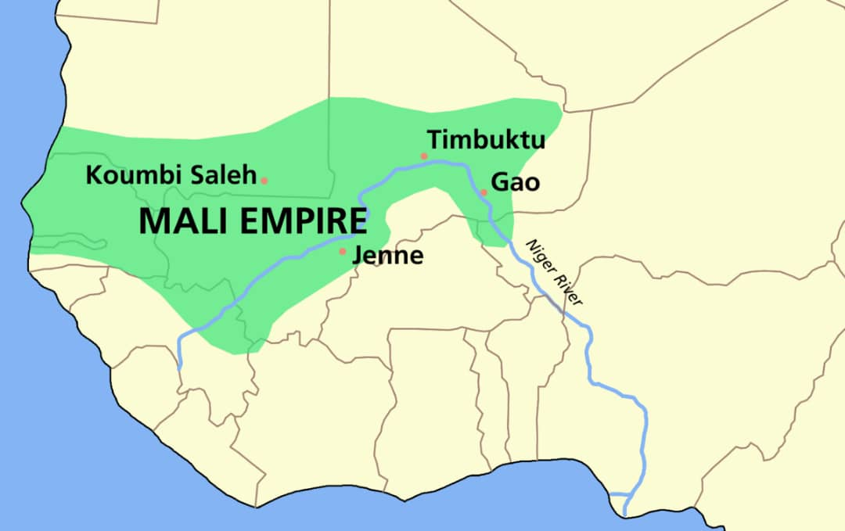
Discuss the contribution of Sundiata Keita in terms of expansion, government and religion.
- Expansion
Sundiata Keita expanded the Mali kingdom through conquests. He conquered the famous towns of Timbuktu, Djenne and Gao in the north. Timbuktu, Jenne and Gao were trading centres of caravan trade.
He also conquered the gold-producing regions of Wangara and Bambuk. Sundiata Keita contributed to the prosperity of the kingdom of Mali by taking control of the gold-producing regions.
- Religion
Sundiata Keita helped in the spread of Islam. In 1076 AD Ghana was invaded by Almoravids, a group of Muslim Berbers.
The Almoravids invaded Ghana kingdom in order to convert people to Islam
Through trade contacts with the Muslim Arab traders, the Keita had long embraced Islam. During the reign of Sundiata Keita, Mali was drawn closer to other Muslim states. In fact, it was during his rule that Islam was accepted throughout the empire.
- Government
Sundiata Keita created an effective system of government. He divided the kingdom into provinces each under a trusted governor. The governors were mostly military governors who intended to control the troublesome vassal states. In so doing, Sundiata helped maintain Mali as a united country.
Discuss how Sundiata ensured unity of Mali.
Sundiata Keita created an effective system of government. He divided the kingdom into provinces each under a trusted governor. The governors were mostly military governors who intended to control the troublesome vassal states. In so doing, Sundiata helped maintain Mali as a united country
Discuss the factors that led to the rise and expansion of Mali kingdom.
- Trade
The kingdom became wealthy from control of the rich gold deposits of Wangara and the salt deposits of Taghaza. Gold was the main trade item and was on high demand in the Middle East and Europe. The king controlled the trade routes and levied taxes on all the gold that passed through his country. The king used the taxes to run the country.
- Efficient government
The king of Mali created an efficient and well organised government. As a result, there was order and peace in the country. Stability was important for trade to grow.
- Environment
Mali kingdom was located in the Niger River which allowed the people to produce sufficient food. They grew crops such as rice, millet and sorghum. It was also suitable for cattle keeping.
- Conquest
Sundiata Keita conquered the gold-producing and salt-rich regions. These conquests led to the capture towns and vassal states.of important
- Islam
Sundiata Keita helped in the spread of Islam. In 1076 AD Ghana was invaded by Almoravids, a group of Muslim Berbers.
The Almoravids invaded Ghana kingdom in order to convert people to Islam. Through trade contacts with the Muslim Arab traders, the Keita had long embraced Islam. During the reign of Sundiata Keita, Mali was drawn closer to other Muslim states. In fact, it was during his rule that Islam was accepted throughout the empire
Discuss the role of Mansa Musa in the expansion of Mali Kingdom.
Mansa Kankan Musa expanded Mali kingdom as far as Atlantic Ocean and the Berber settlements in the North. The nomadic Berbers paid tribute to the king of Mali which strengthened the empire.
When visited Mecca and on his return from Mecca, his army captured Gao, the capital of Songhai. Its king was killed and his two sons were taken captive to ensure loyalty.
In what two ways did Mansa Musa contribute to the growth of Mali?
- He expanded Mali Kingdom by conquering areas as far as Atlantic Ocean and the Berber settlements in the north. He also captured Gao, the capital of Songhai kingdom.
- He conquered lands which were the source of wealth and power to Mali. This made Mali to control trade in gold. Mali controlled the trade routes that connected the gold producing fields of Wangara in the South and the salt regions of Taghaza that passed through Mali.
- He also helped to spread the Islamic religion. Many other people followed the example set by their ruler. People also gained from Islamic learning.
Mention two trade items in Mali.
- The main trade item of Mali kingdom was gold. Other trade items were slaves, ostrich feathers, salt and salt ivory. They traded with Arabs who crossed the desert into Mali.
- In exchange, the people of Mali acquired textiles, iron weapons, spices, glass and the like.
- The king collected duties on certain imports such as horses, copper and salt.
Explain the achievements of Mansa Musa in the kingdom of Mali.
- He expanded Mali Kingdom by conquering areas as far as Atlantic Ocean and the Berber settlements in the north. He also captured Gao, the capital of Songhai kingdom.
- He conquered lands which were the source of wealth and power to Mali. This made Mali to control trade in gold. Mali controlled the trade routes that connected the gold producing fields of Wangara in the South and the salt regions of Taghaza that passed through Mali.
- He also helped to spread the Islamic religion. Many other people followed the example set by their ruler. People also gained from Islamic learning.
Discuss the system of government in Mali.
- Mali was ruled by a king whose title was Mansa who was assisted by a royal council. The vassal states which were conquered by Mali kingdom existed as provinces of Mali. The king put governors in each province and these governors were often members of the royal family or slaves.
- Below the king, were the mocrifs who governed towns and villages. They ensured that the ‘lesser chiefs’ remained faithful to the mansa. They collected taxes and tribute for the king so that the state funds were enough for the government.
- Other officials at the royal court included the praise singers and the master of granaries who looked after royal granaries.
- The king kept a large well-equipped army. The army was provided with bows and arrows. From the state treasury, the king armed the army with expensive Arab horses and iron weapons.
- The army was important to Mali because it helped to defend the empire against attacks, to guard trade routes and to act as an instrument for forcing the vassal chiefs to pay tribute.
State three functions of slaves in Mali.
- They were king’s personal body guards.
- They were king’s advisors.
- They were appointed to become governors of the province.
Suggest the reason why the governors were drawn from the royal family or slaves.
They prevent rebellion against him or to ensure that they were loyal to him.
Describe the contribution of Islam to Mali kingdom.
- Mansa Musa brought scholars and architects from Mecca. The architects built fine mosques in Gao, Timbuktu, and Djenne. The famous Sankuru Mosque at Timbuktu was built by these architects.
- The Muslim scholars he brought set up a university at Timbuktu. Timbuktu became the important centre of learning. It produced Muslim teachers who went to teach in other parts of West Africa. In the process, they propagated Islamic faith and culture. This is how Islam spread to Nigeria.
- Finally, scholars who benefited from Muslim education were often employed by rulers to serve in the education.
- Islam also exposed Mali to the rest of the Islamic world. Arab travellers were attracted to Malawi. This increased trade with both the Islamic world and Europe. As a result, the country prospered enormously.
Name the Moroccan Arab traveller who described much about Mali in 1352AD.
Ibn Battuta visited Mali Kingdom in 1352. He was impressed with life there; the strict observance of law and order, the devoutness of the Muslim faith and the respect given to the king.
Discuss factors that led to the decline of ancient Mali kingdom.
- Succession disputes. Following the death of Mansa Musa, the kingdom began to decline. His successors were also weak. This led to succession disputes among his grandsons. Such succession disputes led to civil wars.
- Mali kingdom was attacked Tuaregs in the north, the Wolof in the west and the Mossi entered the south.
- Sonni Ali of Songhai invaded and founded a new kingdom that included Mali territories.

UNIT 8: THE BUGANDA KINGDOM
Describe the origin of Buganda kingdom
- The founders of Buganda kingdom were the Ganda. Their legendary chief was Kintu.
- The Ganda came from Mt.Elgon on the boarder between Kenya and Uganda.
- The ancestors of the Ganda were the Bachwezi and other descendants of the Bachwezi were the Nyoro and Ankole.
- Previously, the Ganda were under the influence of Bunyoro, a more powerful kingdom whose rulers were the Bito chiefs. The Nyoro often territorised their neighbours; Busoga, Ankole and the Ganda.
Kabaka Mutesa, the eleventh king defeated the armies of Bunyoro at the battle of Mbale. Then Buganda expanded into neighbouring countries.
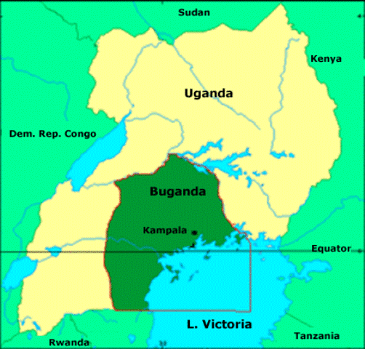

Explain the factors that led to the growth of Buganda Kingdom.
- Trade
The Ganda conducted trade-in ivory with the Nyamwezi who lived in the South of Lake Victoria. They acted as middlemen for the Swahili and the Arabs at the coast. From Buganda, they obtained ivory which they exchanged with cloth at the coast.
By 19th century, the demand for slaves increased. Consequently, the Swahili and the Arabs moved into the interior of Buganda to control trade. They brought guns and cloths which they exchanged for slaves and ivory. Buganda raided neighbouring chiefdoms especially Bunyoro for ivory and later for slaves.
- Geographical location
The location of Buganda along the shores of Lake Victoria enabled the Ganda to benefit from the trade with the Arabs and the Swahili. The Ganda controlled trade activities along the shores. It was therefore, easier for the foreigners to trade with Buganda than Bunyoro. As the result, Bunyoro was denied access to guns from the Arab traders. Because of this, Buganda was able to defeat Bunyoro and rise to prominence.
- Size of the kingdom
The kingdom was small and compact. It was easy for the king to rule from his royal court.
- Warfare
Guns acquired from trade with the Swahili Arabs proved very important to the growth and strength of Buganda. It helped strengthen the military which was vital for warfare. The soldiers were armed with guns and spears. During the reign of Mutesa, a canoe fleet was expanded under special navy officer. The army was used to expand the kingdom.
- Agriculture
Buganda Kingdom was established in an area that received good and reliable rains. It had fertile soils. This enabled farmers to grow plantains which are banana-like fruits. The plantains produced food all the year round. The made people to concentrate on other socio-economic activities such as metal working, carpentry and others.
- Stability
Buganda kingdom established strong centralised government which helped to create stability in the kingdom.
- Infrastructure
Buganda kingdom built good roads which were well maintained. It was easy for the soldiers to move and defend the borders in case of war threat. In addition there was improved communication as it was easy to reach various parts from the royal courts. Lastly, the Kabaka could also trade from the shores using the roads
- Foreign contact.
In 1850, the Arabs entered Buganda entered Kingdom to look for ivory and slaves which were exchanged mainly for cotton cloth and guns. Being a new product, cotton cloth was quite valuable. The cotton cloth was worn by the loyal class. Buganda’s contact with foreign traders not only increased the wealth of the country but it also strengthened the power of the Kabaka.
CENTRALISED SYSTEM OF GOVERNMENT
- The ruler of the Buganda was called Kabaka. Each province was governed by a hereditary clan who were known as Bataka.
- At first, the Kabaka did not have a complete authority over the Bataka. The role of the Kabaka was to settle disputes among the clan heads.
- The centralised government rose in the Buganda kingdom due to the constant outside attacks which convinced the clan heads about the need for unity under one central authority. It was Kabaka Junju who began a centralised administration after ending the system of hereditary clan heads. Instead, he appointed clan leaders of his own choice. The system became fully developed during the rule of Kabaka Mawanda and later, Kabaka Mutesa who further expanded the kingdom.
State five system officials which were found in Buganda Kingdom.
- Katikiro- Chief Minister
- Omulamuzi – Chief Justice
- Omuwanika- The Treasure
- Mujasi- Army commander
- Gabunga – naval commander who was in-charge of a fleet of canoes.
- Lukiko- Council of chiefs who advised the king.
Discuss the factors for the coming of the Swahili- ARABS IN Buganda kingdom.
- There were searching for ivory and slaves.
- They wanted to introduce Islamic .
Discuss the impacts of the Swahili and the Arabs on the Buganda Kingdom.
- They converted Kabaka Mutesa to Islam and many other people embraced.
- Long distance trade with Arabs led to the introduction of foreign goods such as cotton and guns.
- The introduction of guns improved the military strength of the kingdom. This made the kingdom to defend itself easily.
- The arrival of the Arabs and Swahili increased slave trade in the kingdom
- The authority of Mutesa was weakened because Muslim teachers taught people a stricter version of Islam. This made some of Mutesa’s people to challenge his authority. In order to protect his position, Mutesa began persecution of Muslims in Buganda.
Mention the Europeans who visited Buganda Kingdom in 1860 during the reign of Kabaka Mutesa.
John Speke and James Grant.
State two reasons why European explores and missionaries came to Buganda.
- To spread Christianity
- To introduce Western Education
Mention the European who visited Kabaka Mutesa in 1874 and recommended the need for the spread of Christianity in Buganda kingdom.
Henry Morton Stanley.
Which European Missionaries arrived in Buganda Kingdom in 1877 to spread Christianity and introduced Western Education?
The Church Missionary Society of Anglican Church and they were followed by the White Fathers.
Discuss the impact of European explorers and missionaries on Buganda kingdom.
- They introduced Christianity in Buganda.
- Traditional religions lost popularity.
- Western education was introduced.
- Slave trade was abolished
- They led to colonisation of Buganda.
What led to the decline of Buganda Kingdom?
After the death of Mutesa in 1884, Mwanga succeeded as Kabaka. The growing influence of Christianity in the kingdom was seen as a threat to his power. This attitude was strengthened by the news that Tanganyika had been colonised by Germany. He had also learnt that this colonisation was between Germany and Britain. Thus Mwanga suspected that the presence of missionaries in the kingdom was an attempt by Europeans to rule Buganda. This led to persecution of Chritians.
What followed were successive religious conflicts which affected the position of the Kabaka. In 1888 Mwanga was overthrown. But he was restored in 1890 with the help of Christian groups. By this time, the position of the Kabaka had weakened. The situation forced Mwanga to sign a treaty with the British East Africa Company. The treaty gave the company mandate to govern Buganda.
As the religious conflicts between Catholics (Wa-Fransa) and Protestants (Wa-Ingliza) turned more violent, the British declared Buganda a British protectorate.

UNIT 9: THE MWENEMUTAPA KINGDOM
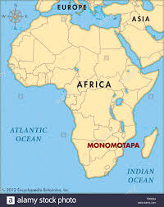
Explain the origins of the Mwenemutapa.
- The founders of Mwenemutapa kingdom were the shone, a group of the Bantu speaking people.
- The shone migrated from Katanga region in Zaire. The first person to rule over several chiefdoms of the Togwa, Karanga and Rozwi was Chikurawadyambewu from the Mbire clan.
- In 1420, Nyatsimba Mutota came to the throne and founded the Mwenemutapa dynasty after the decline of Great Zimbabwe. He extended control over vast areas through conquests.
What was the role of the Great Zimbabwe?
- The kingdom was created by the ancestors of the Shona people between 12000 and 1300AD.
- The name Zimbabwe comes from Dzimba Dzambabwe which literally means “stone buildings” The buildings were made of stones without mortar.
- The Great Zimbabwe is one of the Seven Wonders of the World.
- The stone buildings consisted of three groups
- Acropolis
This was at the hill-top which had built for prestige. They designed for defence.
- Great Enclosure
This is where the king as a divine ruler lived. There also other loyal houses.
- Valley Walls
This is where the ordinary people built mud and thatched huts
- Great Zimbabwe was perfectly positioned. Being in the valley and along the hill, the area had fertile soils and enough grazing fields. This was good for crop production and for cattle-keeping. The people were also engaged in trade with the East Coast. They traded in gold, ivory and iron ore.
Explain how the decline of the Great Zimbabwe influenced the rise of the Mwenemutapa.
- By 1450, Great Zimbabwe had declined and it was abandoned because of the following reasons:
- Soil had lost its quality and fertility. As such, it could no longer support the population of people and livestock.
- There was shortage of salt and other supplies.
- The gold trade upon which the kingdom relied had moved north to Zambezi region.
- The decline of Great Zimbabwe allowed Nyatsimba Mutota to conquer the Korekore and Tavara of the Dande and Chidema areas. He finally moved the capital to Dande, in the north on the edges of the Zambezi valley. Eventually, Mutota founded the Mwenemutapa dynasty.
Discuss the factors that led to the expansion of the Mwenemutapa Kingdom
- Role of Nyatsimba Mutota
- Nyatsimba Mutota expanded the kingdom through conquests. He conquered chiefdoms such as the Sotho, Tonga, and Tavara in order to control vast areas for trade.
- Mutota’s army had skilful warriors and the Tavara nicknamed Nyatsimba Mutota Mwenemutapa which means ‘Master Pillager’ or Lord of Plundered Lands.
- There were three reasons for Nyatsimba Mutota’s expansion policy and these included
- The resources at Great Zimbabwe had diminished, there was growing need to acquire more land in order to access natural resources in order to solve the problem of human and livestock population necessited expansion
- He wanted to establish control over the booming gold and ivory trade in the Zambezi area.
- He wanted to build a huge empire.
- Trade in Gold
Mwenemutapa kingdom established trade with the Swahili Arabs and the Portuguese. The trade items include
- Personal ambition
The personal of Nyatrimba Mutota was trove hin interwove to seize more territory
- Advice from Arab traders
Nyatsimba Mnutota
- Hunting expeditions
Nyatrsimba Mutota wanted to expand the kingdom northwards into the Zaire.
- Fertile soils
The availability conquer and occupy their land such sorghum and millet etc
- Industries and crafts
Mwenemutapa carried in one ore from the streams and heated it meltdownthe shone also made beads and
Centralised system of government
- The Menemutapa kingdom created a highly centralised government with the king as a supreme. The king was a divine and so he had to be hidden from ordinary people.
- The king’s health was associated with the prosperity of the kingdom. When he was healthy, the kingdom was regarded to be strong. For this reason when he became old or seriously ill, he had to commit suicide often by taking poison. This was done to save the welfare of the state.
- At the royal court, the king was assisted by the following officials: The chancellor, Court chamberlain, Military commander, Head drummer and Chief cook etc
- The king had nine official wives who played an important role in state affairs.
- Below the king was the advisory council which comprised nobles and elders. There were also subject chiefs who governed the conquered chiefdoms or provinces such as Bare, Manyika, Uteve and Guruhuswa.
- The chiefdoms paid tribute to the Mwenemutapa in form of cattle, gold, iron and food.
- The king had a standing army to control the provinces and to prevent or crush rebellion.
THE ROYAL FIRE
- The Royal Fire burned continuously throughout the rule of a king as a symbol of his authority. Once a new king began his rule, chiefs and village heads had to relight the fire as sign of royalty. Each year, messengers were sent out with torches of the fire to the chiefs. Any chief or village head that refused was considered disloyal and punished.
In what two ways was the Royal Fire important during the Mwenemutapa kingdom?
- The Royal Fire burned continuously throughout the rule of a king as a symbol of his authority.
- Once a new king began his rule, chiefs and village heads had to relight the fire as sign of royalty.
RELIGION
- The Shona believed in the supreme god called Mwari.
- Religion played a considerable role in the Shona political system. The spirits of the dead ancestors, the mhondoro, were directly involved in the affairs of the state.
- In times of crisis such as draught, they interceded with Mwari on behalf of the living. They also intervened in succession disputes of chiefs or clans.
- The mhondoro spoke through spirit mediums called the masvikiro whose role as priests was highly regarded.
- The messenger of Mwari was a bird called Hungwe. The image of this bird is included on the flag of Zimbabwe. Only the masvikiro interpreted the whistles of the Hungwe. The interpreted message was then told to the people.
- Religion played an important role in the society. It enhanced loyalty to the king he was directly linked to the ancestral spirits. It also encouraged unity as it reminded them of their common ancestry For instance, when the religious priests urged people to drive out the whites out of their land, the Shona united against the white settlers in 1897. Infact, the 1897 Shona revolt ended after the capture of the masvikiro.
In what two ways was the religion important during the Mwenemutapa kingdom?
- It enhanced loyalty to the king he was directly linked to the ancestral spirits.
- It also encouraged unity as it reminded them of their common ancestry For instance, when the religious priests urged people to drive out the whites out of their land, the Shona united against the white settlers in 1897. In fact, the 1897 Shona revolt ended after the capture of the masvikiro.
What factors led to the decline of the Mwenemutapa kingdom?
- After the death of Matope, the son of Nyatsimba Mutota, the kingdom began to decline after his death. His successor Nyahuma was young and weak. Some subject chiefs took advantage to break away.
- In 1490, change, the governor of Guruhuswa rebelled and killed Nyahuma and started the Changamire dynasty based at Great Zimbabwe while Mwenemutapa remained in the north. This affected the kingdom because most of the gold fields were in the south.
- The Portuguese by-passed the king and trade with Changa directly. As a result, the Mwenemutapa lost control of trade on which the wealth and power of the kingdom rested.
- Around 1600, some Portuguese traders settled in the Zambezi valley where they set up plantaions called prazeros which relied on slave labour. Their slave armies, known as the Chikunda frequently terrorised the kingdom. This further weakened the kingdom.
- In 1632, the Portuguese killed Kapararidze and installed Mavura as new Mwenemutapa and the kingdom had to pay tribute to the Portuguese. Africans were reduced to a subordinate position.
- In 1693, Changamire attacked and drove out the Portuguese from the country. This was the beginning of the Changamire kingdom.
Explain how the Portuguese contributed to the decline of Mwnemutapa.
- The Portuguese by-passed the king and trade with Changa directly. As a result, the Mwenemutapa lost control of trade on which the wealth and power of the kingdom rested.
- Around 1600, some Portuguese traders settled in the Zambezi valley where they set up plantaions called prazeros which relied on slave labour. Their slave armies, known as the Chikunda frequently terrorised the kingdom. This further weakened the kingdom.
- In 1632, the Portuguese killed Kapararidze and installed Mavura as new Mwenemutapa and the kingdom had to pay tribute to the Portuguese. Africans were reduced to a subordinate position.
- In 1693, Changamire attacked and drove out the Portuguese from the country. This was the beginning of the Changamire kingdom.
What do you understand by the following terms?
- Masvikiro
- These were the human spirit mediums through the Mhondoro spoke to the Shona god Called Mwari.
- Mhondoro
- They were the spirits of the dead ancestors who were directly involved in the affairs of the state.
- Prazeros
- These were the Portuguese plantations set up in the Zambezi valley which relied on slave labour.
- Chikunda
- These were the Portuguese slave armies who frequently terrorised the Mwenemutapa kingdom

UNIT 10: THE TRANS-ATLANTIC SLAVE TRADE
What is the difference between slave, slavery and slave trade?
- A slave is a person who is owned by another person as her or his property.
- Slavery is the act of owning or being a slave.
- Slave trade is buying and selling of slaves.
ORIGINS OF SLAVE TRADE
ASIA
- Slavery had been known to exist in Asia for century before the birth of Christ.
- The Arabs were actively involved in buying slaves in and West Africa
- There were several ways how the slaves being used and these included
- They were being used for domestic purposes such as farming and mining.
- Male slaves looked after their master’s women or daughters. Such slaves who served their master’s women and daughters were castrated and were called eunuchs
AFRICA
- Egypt is the first nation to keep slaves in Africa. Slaves in Egypt were used in the construction of pyramids at Gizah. Ancient Israelites served as slaves in Egypt.
- In West Africa, slaves were kept for farming purposes and sometimes used as soldiers. They also assisted in government services at the royal courts.
- The Arabs crossed the desert to West Africa to buy gold and slaves and exported them to the Middle East.
AMERICA
- It is known that slavery existed in the civilised ancient empires of Aztec and Toltec (Mexico), the Inca (Peru), Chibcha (Colombia) and the Maya (Guatemala).
THE PORTUGUESE
They were the Europeans to take slaves from Coast of West Africa and supplied them to the Spanish.
List three ways in which slaves were used.
- Slaves in Egypt were used in the construction of pyramids at Gizah.
- Slaves were kept for farming purposes and sometimes used as soldiers.
- They assisted in government services at the royal courts
- They were being used for domestic purposes such as farming and mining.
- Male slaves looked after their master’s women or daughters.
THE TRANS-ATLATIC SLAVE TRADE
The Trans- Atlantic Slave trade is buying of slaves from Africa crossing with them through Atlantic ocean and selling them to the owners of the plantations in new world (Central and South America).
Explain four reasons for the growth of the Trans-Atlantic slave trade.
- Demand for labour in the mines and plantations in the Americas. The Europeans who settled in America established plantations and mines. They produced coffee, sugar cane, tobacco and cotton on the plantations which needed slaves to work on them. Mining activities involved exploitation of silver and gold. The plantations required cheap labour in form of slaves. When the use of Native Americans, the Red Indians failed, they resorted to obtaining slaves from Africa.
- Industrialisation of Europe
- The industrial revolution which developed in Europe led to the growth of Trans-Atlantic slave trade. There was demand for raw materials for the manufacture of various goods such as cloth. The raw materials could only be supplied with the help of slave labour. The slaves were used to carry the raw materials such as ivory from African Cost due to the absence of effective modern communication such as roads and railway networks.
- Ivory was used for making handles of kitchen utensils, piano keys, billiard balls, chess materials and ornaments of various kinds.
- Demand for manufactured goods in Africa.
- The Trans- Atlantic slave trade also expanded because of the demand for manufactured goods among African societies. The Africans wanted to high quality European goods such as cotton cloth which of higher quality than bark cloth.
- The African rulers found the slave trade more profitable and could not resist selling their subjects. They wanted to exchange slaves with guns which provide military advantage over those societies which did not possess them.
- In order to obtain slaves, tribal war was being used in order to obtain captives who could be sold out in exchange for foreign manufactured goods such as cloths, gin, glassware and guns.
- Pro-existence of slavery in African societies
- Most African societies had been keeping slaves for centuries before the arrival of foreign traders. As there were no prisons, criminals, witchcraft suspects or the lazy were being punished as slaves. Therefore, Africans saw nothing evil in selling fellow human beings to Europeans.
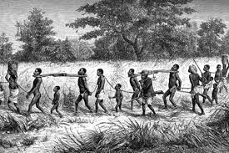

THE GREAT TRAINGLE ROUTE
Draw a triangle to represent the Great Triangle route and indicate the trade items passing on each of the triangle sides
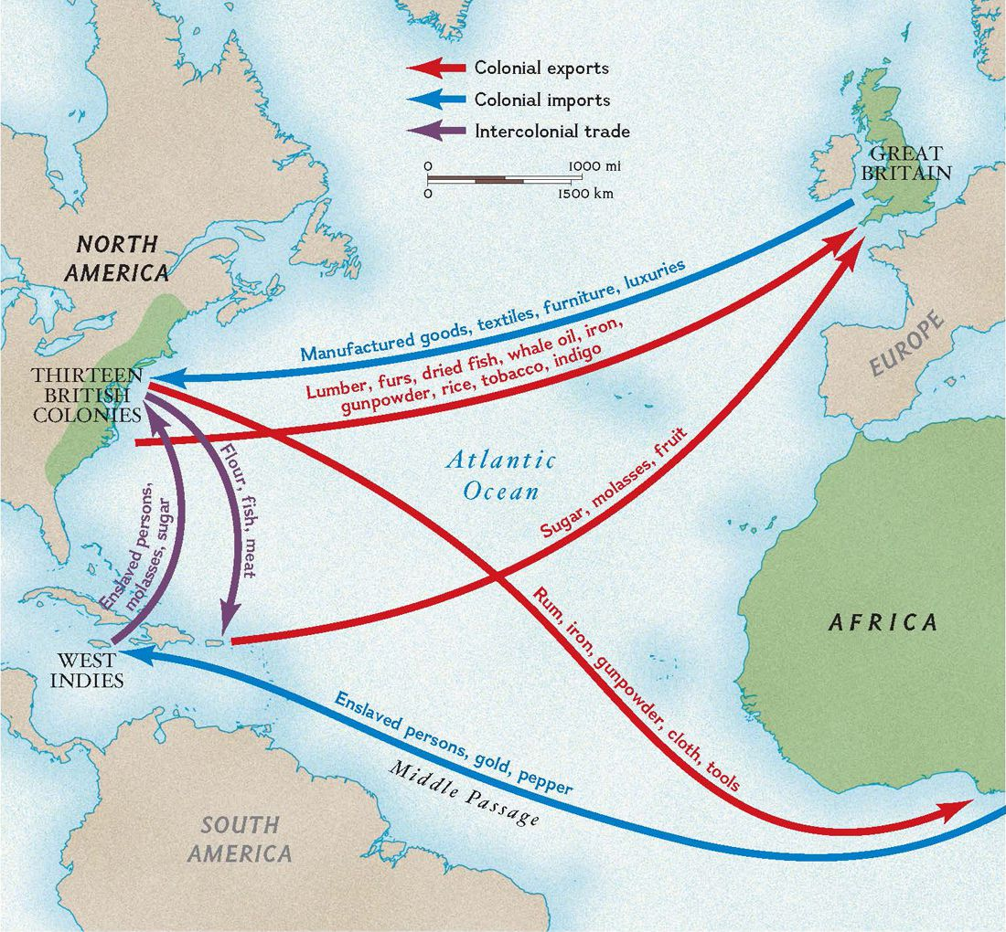
FROM EUROPE TO AFRICA
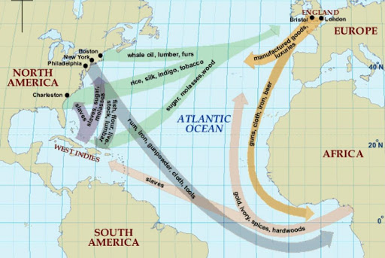
Slave traders carried with them various manufactured goods such as guns, cotton cloths, gin, glassware and raw materials such as metal, axes or hoes to exchange with slaves from Africa.
FROM AFRICA TO EUROPE ACROSSING ATTRANTIC OCEAN
Slave traders carried slaves in their ships across the Atlantic Ocean to America and West Indies. The route is called the Middle Passage.
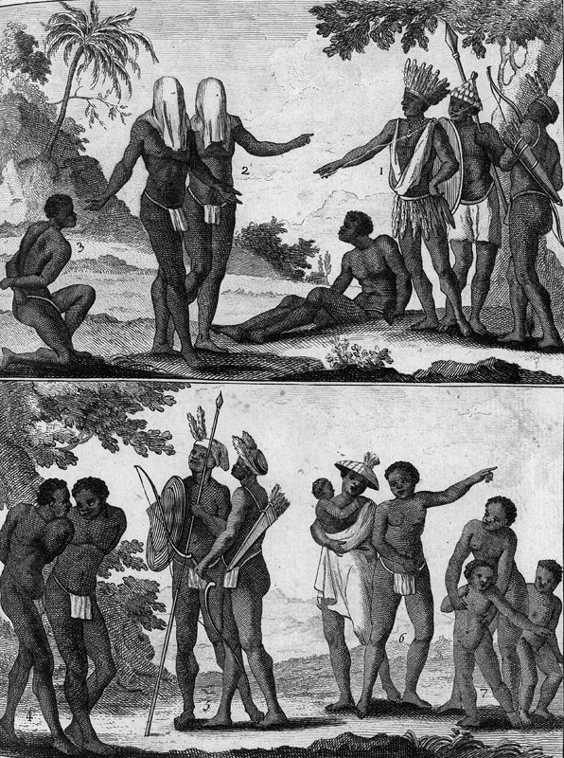
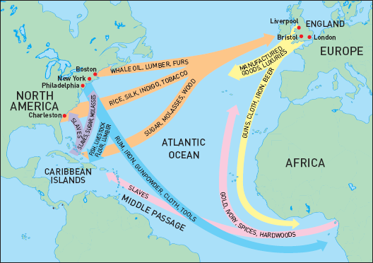
Conditions that the slaves were subjected to across the Middle Passage:
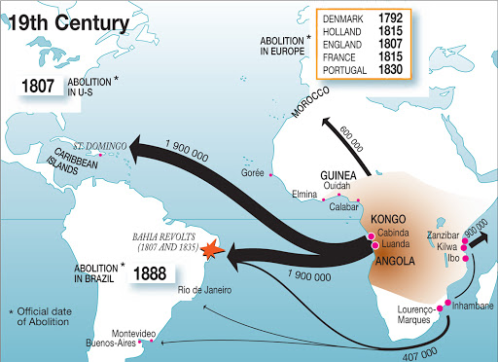
- They chained tightly together and packed that it was not easy to even move
- They were overcrowded and a result some of them were dying before reaching America.
- Food and fresh water were most of times not enough.
- Those who were quite ill and weak were simply thrown into the ocean
In America, the slaves were made to work on the plantations and some worked as house servants in their master’s homes.
FROM AMERICA TO EUROPE
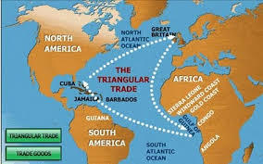
The slave traders carried cotton, sugar and tobacco to Europe.
Mention two industries in which slaves worked in North and Central America.
Plantation industry
. The Europeans who settled in America established plantations and mines. They produced coffee, sugar cane, tobacco and cotton on the plantations which needed slaves to work on them.
Mining industry
Mining activities involved exploitation of silver and gold. The plantations required cheap labour in form of slaves. When the use of Native Americans, the Red Indians failed, they resorted to obtaining slaves from Africa.
State the problems slaves faced on the route to America OR West Indies.
- They chained tightly together and packed that it was not easy to even move
- They were overcrowded and a result some of them were dying before reaching America.
- Food and fresh water were most of times not enough.
- Those who were quite ill and weak were simply thrown into the ocean
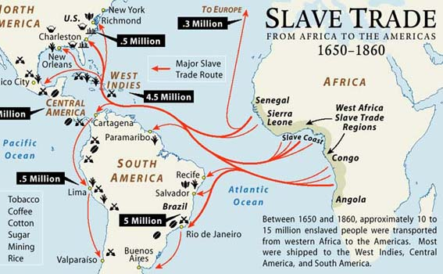
THE EAST AFRICA SLAVE TRADE
Mention the reasons why slave trade took so long to end.
- Slave trade was profitable business. During the 18th Century when the trade reached its peak, slaves yielded huge profits. Africans at the West Cost were bought for mere beads, gin or cloths and were sold in MERICA AND THE West Indies at £15 or £35 per person. It therefore, not easy for traders t stop it. Consequently, Africa societies driven by desire to obtain foreign items, could hardly stop selling human beings as slaves.
- Slaves provided very valuable but cheap labour on the plantations and mines. Slaves had to work for the owner for as long as she or he was alive. Consequently, slave owners strongly believed that loss of slave trade was made illegal, many traders still smuggled slaves to the Americans.
- Slave trade was prolonged by mistaken belief that only African slaves could do hard work.
- Some plantation owners were connected to political figures in Europe. It was, therefore, difficult to pass laws forbidding slave trade and slavery.
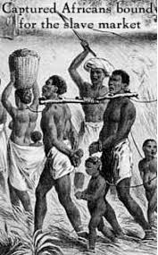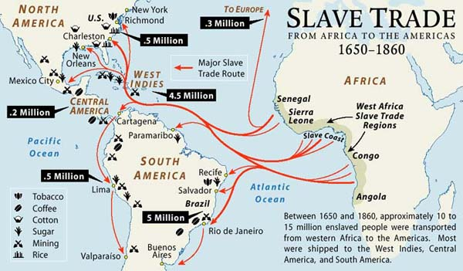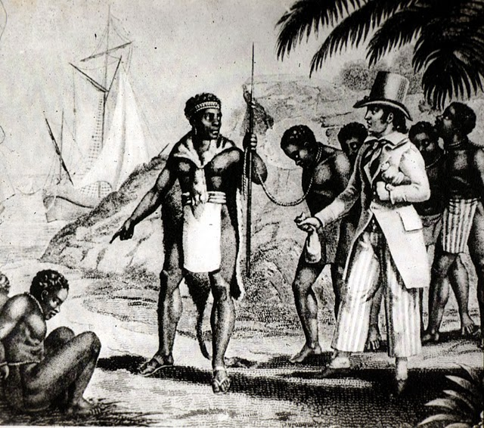
Discuss the stages in the abolition of slave trade in
- Europe
- The road to the ending of the Trans-Atlantic slave trade with the British.
- The most outstanding of the abolitionists in Britain were William Wilberforce, Thomas Clarkson and Granville Sharp
- In 1807, the British parliament passed a law that prohibited slave trade throughout the British Empire.
- By 1820, all European countries made slave trade an illegal business.
- In 1n 1833, the British passed a law that freed slaves in the British Empire.
- Therefore, Britain became the first country to abolish slave strade.
- America
- The northern states in the United States of America were the first to make slavery illegal.
- Harriet stove began to campaign for the emancipation or liberation of slaves in the USA.
- In 1863, President Abraham Lincoln proclaimed the liberation of all slaves.
- Slavery came to an end in 1865 in the USA when the proclamation officially came into effect.
- Africa
- The abolition of the East Africa trade was a result of the efforts of the British.
- In 1822, Sultan Seyyid Said agreed not to sell slaves to Christian countries.
- In 1845, an agreement was made between the Sultan and the British which forbade the export of slaves to areas outside the Sultan’s control and to Oman. This agreement was ineffective because it left out his territory. This made slaves continued to be taken to be exported into the Sultan’s territory.
- Slave trade ended in East and Central Africa after Dr. David Livingstone visited the area. When he went back to England, he publicised the evils of slave trade which provoked a second attempt by the British to end slave trade.
- The British signed a number of treaties with the Sultans of East Africa such as the Morseby and the Hammerton agreements but none was successful in ending slave trade in the region.
- In 1870 the British Government appointed Sir John Kirk as the British Consul to Zanzibar.
- Sir John Kirk and Sir Battle Frere signed the Barghash Treaty with Sultan Barghash in 1873. The Barghash Treaty forbade the sale and export of slaves from the Sultan’s territories. It ordered the immediate closure of the Zanzibar and Kilwa slave markets.
- The land which the Zanzibar market stood was bought by UMCA and a church was built there. However, slave movements continued until in 1876 when Kirk persuaded the sultan to prohibit the import of slaves from the interior.
- However, Swahili- Arabs and African agents continued with slave trade in the interior.
- In the 1890s the British agents began military campaigns aimed to end slave trade and pacify the region.
- Finally, the colonisation of the region marked the abolition of slave trade in East and Central Africa.
Discuss the contributions of the leading personalities in the abolition of slave trade.
- Granville Sharp
- He became famous when in 1772 he defended a slave named James Somerset who had escaped from his master. James was recaptured and was about to be returned about to be returned to Jamaica. In his ruling, Lord, Lord Chief Justice Mansfield declared that slavery was illegal in England, Ireland and Wales. This was the first step towards the abolition of slave trade in Britain.
- In 1787, Granaville Sharp, founded the Abolition Society. He vigorously campaigned against slavery.
- William Wilberforce
- He used his role as a Member of Parliament to ensure that ant-slavery laws were passed. He was mainly influenced by his Christian beliefs so that he felt it was good to help fellow human beings to be free. He used evidence collected by the Abolition Society to convince the British Parliament to pass anti-slavery laws.
- In 1791, William Wilberforce unsuccessfully introduced an anti-slavery bill in the parliament.
- In 1807, the British Parliament passed law which abolished slave trade throughout the British Empire. In addition, all British ships were forbidden from taking part in slave trade. This meant it was illegal to buy or sell slaves in all British colonies. This law forbade slave trade only in the British Empire and not outside it.
- In 1833 British passed a law that abolished slave trade
- In order to completely end slave trade, many European nations signed ‘The Right to Research” agreement with Britain. This agreement allowed the British navy the right to stop and search any ship suspected of carrying slaves. If they caught that ship, the British could free the slaves. Until the beginning of the 1900s, only Britain had a strong navy that could stop slave
- Thomas Clarkson
- A University of Cambridge scholar, he tirelessly collected information about the conditions of slaves.
- He visited slave markets and slave ships to see for himself the conditions of slaves on the plantations and in mines as well as on the slave ship.
- He publicised his findings in meetings and in pamphlets. This helped many people in Britain become aware of the evils of slave trade.
- Harriet Beecher Stowe
- She wrote a novel called Uncle Tom’s Cabin in which she narrated shocking stories of slaves based on true stories about the experiences of runaway slaves.
- Abraham Lincoln
- He elected the 16th American President in 1861. This was the time when the northern states had already abolished slavery.
- In 1863 Abraham Lincoln issued the Emancipation Proclamation. Under this law, slaves were legally freed. The southern states were not happy. Consequently, Civil War broke out in which the Confederates lost.
- Finally, in 1865 slavery was declared illegal in the USA.
- In the same year of 1865, the American Colonisation Society set up a settlement for the freed slaves in Liberia whose capita; was Monrovia which was named in honour of the American President Monroe.
Discuss the challenges encountered by the abolitionists in the abolition of slave trade.
- They faced opposition from politicians who had great influence in the British parliament. Most of these politicians were slave owners and wealthy.
- Due to the increasing demand for slaves in America which helped the traders gain huge profits, it became difficult to enforce the ant-slavery laws as slaves were still smuggled across the Atlantic Ocean.
- Other European nations refused to give the British the ‘Right of Research’ over their ships. The British naval ships had no ‘right of research’ over ships from America and those European nations who had not signed the agreements.
- Most slave ships were faster than the naval vessels sent to stop them.
- New routes were created by slave dealers in order to avoid British anti- slave campaigns.
Discuss the positive and negative effects of the slave trade on people and the areas affected.
Positive impact/effects of slave trade
- Growth of towns. some towns such as Nkhota kota, Karonga and Kilwa were developed
- Food security
It led to the introduction of new crops into the interior of Africa. Such crops included maize, rice, citrus fruits and coconuts. These crops enhanced food security in the region
- Economic growth
Slave trade helped in the economic growth of America and Europe. The plantations and mines provided valuable resources which brought a lot of wealth to business people.
- Growth of western and oriental culture
It helped Africans to copy western culture through education and languages which were result of the Christian missionaries who aimed to end slave trade. Similarly, contact with the SWAHILI Arabs resulted in African societies copying Arabic culture such as languages, dressing and building styles..
- Adoption of foreign religions
Slave trade led to the introduction of foreign religions into the interior. For example, contact with the Swahili- Arabs led the Yao to adopt Islam. Christianity was also introduced in parts of Africa as a result of missionary efforts to end slave trade.
- Introduction of new crops.
New crops such as fruits rice, rice, maize and coconuts were introduced in Africa.
Negative impact
- Conflicts- It led to conflicts among African Societies. The acquisition of guns promoted tribal wars among African chiefs.
- Decrease in African populations- Slave trade led to depopulation of African societies. It is estimated that about 40 to 60 million Africans were exported from Africa as slaves. Most of these were young and healthy people who could have contributed to economic growth of the continent.
- Effects on small-scale business activities- Slave trade led to the displacement of small-scale industries and other activities in the affected areas.
- Under-development – Millions of Africans were exported to America and the Near East as slaves. This led to loss of essential human resource which could have developed Africa throughout the period of slave trade.
- Diseases- the interaction with foreign traders encouraged the spread of new diseases to which Africans were not immune at that time. Such diseases included smallpox, syphilis and measles.
- Inhuman treatment of Africa- The conditions under which the African slave worked were inhuman. The slaves were subjected to ill-treatment. They worked from sunset to sunrise without enough food.
Discuss five ways in which slave trade affected Africans.
- Conflicts- It led to conflicts among African Societies. The acquisition of guns promoted tribal wars among African chiefs.
- Decrease in African populations- Slave trade led to depopulation of African societies. It is estimated that about 40 to 60 million Africans were exported from Africa as slaves. Most of these were young and healthy people who could have contributed to economic growth of the continent.
- Effects on small-scale business activities- Slave trade led to the displacement of small-scale industries and other activities in the affected areas.
- Under-development – Millions of Africans were exported to America and the Near East as slaves. This led to loss of essential human resource which could have developed Africa throughout the period of slave trade.
- Diseases- the interaction with foreign traders encouraged the spread of new diseases to which Africans were not immune at that time. Such diseases included smallpox, syphilis and measles.
- Inhuman treatment of Africa- The conditions under which the African slave worked were inhuman. The slaves were subjected to ill-treatment. They worked from sunset to sunrise without enough food.

UNIT 11: THE PARTITION OF AFRICA
Explain the meaning of the terms “Partition of Africa” and “Scramble for Africa”
This was dividing up of Africa into various ‘nation’ states among European nations for economic and political reasons.
Scramble for Africa was the competition between European states to acquire colonies in Africa.
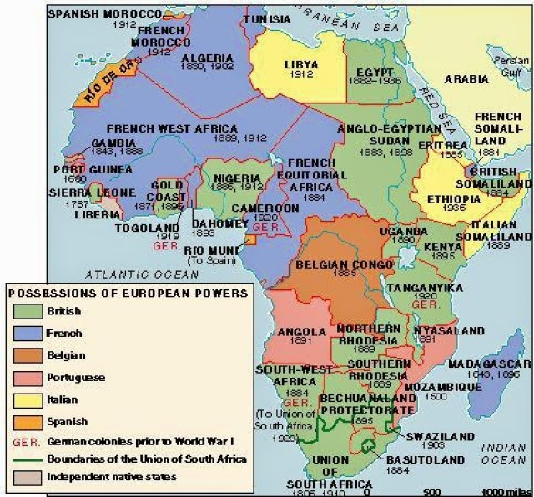
Discuss the political factors that led to the partition of Africa.
- Imperialism
- Imperialism is the system of building up empires by seizing overseas territories. By the close of the 19th century, leading European states were involved in a competitive struggle for international prestige.
- It was a demonstration that a nation had become a first class power. Apart from prestige, the empires were a source of raw materials for flourishing industrialisation in Europe.
- Political rivalries
Political rivalries between European states speeded up the partition of Africa.
In 1871, France was defeated by Prussia, one of the German states which led to the formation of Germany. AS Compensation, French began to colonise territories in Africa. Likewise, the newly created states of Germany and Italy also started to seize territories in Africa. This was aimed to increase trade and to use the empires as bargaining chips. By this, the empires were used to frighten off other nations.
- Strategic importance
- Europeans also wanted to acquire territories in Africa because of their strategic importance. For example, Europeans became more interested in Egypt after the construction of the Suez Canal in 1869.
- The Suez Canal was built by the French but from 1875, it was jointly owned by the British. When the French were pushed out of the canal in 1881, they seized Tunis as a compensation for the loss of their Egyptian investment.
Describe the events leading to the Berlin Conference of 1884-5.
- King Leopold and Congo
- King Leopold of Belgium, a leading statesman became interested in Africa after realised the value of Africa both as a source of raw materials and as a potential market to boost the Belgium industries.
- In 186, he formed the International African Association and became its President.
- In 1879, King Leopold sent Henry Morton Stanley to the Congo region to sign treaties or agreements with the local African chiefs and to bring their territories under Leopold’s control.
- Henry Morton Stanley managed to sign agreements with local rulers in the Congo region and this gave birth to the Congo Free State. Belgium took the administration of the country in 1909.
- Leopold’s activities in Africa worried other statesmen in Europe because the Congo River was viewed as an important route into the interior of Central Africa.
- The Portuguese considered Leopold’s actions a threat to her claims over the coast of Angola and the mouth of the Congo River.
- The French in West Africa and the Congo
- In 1871, France was defeated by Germany and lost her two territories of Alsace and Lorraine to Germany.
- The French therefore sought to recover their prestige by occupying territory in Africa.
- In an effort to bring parts of West Africa under control, the French built railway lines that connected trading points from the Senegal Valley to as as Far as Upper Niger and the Gambia River.
- The British felt that the French action threatened their long established trade interests in Sierra Leone, Gambia, Ivory Coast and the Oil Rives; they also added Dahomey parts of West Sudan and later French Congo.
- In reaction to Leopold’s action, the French sent an Italian explorer Savognan De Brazza to sign treaties with the local chiefs north of Congo which he successfully did. These agreements led to the creation of the French Congo with its capital named Brazzaville.
- The British and the French in Egypt
- In 1869, The Suez Canal was built by the French. She lost control to the British in 1881 when the British helped to put down a rebellion in Egypt. They seized Tunis as a compensation for the loss of their Egyptian investment. Later the French tried to take control of Sudan in 1898. The British felt it was French’s attempt to recover Egypt and the Suez Canal. In reaction, they moved in troops at Fashoda, and threatened war again
- Germany interest in Africa.
- Germany felt left behind in the race for colonies only after the 1880s. To do this effect, Germany declared protectorate over South West Africa (Namibia), Togoland and Cameroon and Tanganyika in East Africa through Karl Peters.
- The British were alarmed at the German moves in Tanganyika. In West Africa, they were not pleased with German claims because it threatened the development of their Cape Colony (South Africa) and partly because of the British missionaries in Bechuanaland and the northern part also did not wish to be under German control.
- Portugal colonised Mozambique and wished to create a large territory from Mozambique to Angola. The feared Germany intended to prevent her ambitions. On the other hand, Portuguese claims threatened the activities of the British nationals in Central Africa.
BERLIN CONFERENCE, 1884
- In order to avoid war among European nations, Otto Von Bismarck, the German Chancellor called for a conference in 1884 at Berlin, the capital of Germany.
- Representatives of leading European governments met to discuss guidelines for a peaceful division of Africa.
- At the conference, guidelines for a peaceful division of Africa. At the conference, guidelines for the partition of Africa were laid down which formed the Berlin Act (1885)
Discuss the guidelines for the partition of Africa.
- Any country that claimed some territory as its ‘sphere of influence’ had to effectively occupy. That is a country had to set up an administration in the area and not just leave it vacant.
- Each country that claimed a territory had to prove to other intending powers that it had legitimate right to occupy the territory.
- Any power that claimed a territory was to suppress slave trade in their territory.
- The Zambezi Basin, the Congo and the Niger Rivers were to be open to the traders of all nations. In a way, the areas could be occupied by a country, but they remain as international trade areas.
- The Congo Free State recognised as the territory of the International AFRICA Association under the control of King Leopold 11 of Belgium. This clause legally confirmed the Congo Free State as Leopold’s personal property. The result was gross exploitation of people for they were subjected to forced labour which amounted to slavery.
State three results of the Berlin Conference, 1884-85.
- The Scramble for Africa stepped up.
- European states began to send their agents to Africa to sign treaties with local African Chiefs
- European powers established administrative systems in their colonies and protectorate.
Why were the following not colonised?
- Abyssinia
The Italians attempted to conquer Abyssinia (Ethiopia) but they were defeated by the Ethiopian forces under Emperor Menelik at the Battle of Adowa in 1896.
- Liberia
Liberia was set up as a settlement for the freed slaves and was, therefore, independent under the influence of the United States of America.
Discuss the positive and negative effects of the partition of African societies.
Positive effects
- The European occupation of Africa ended slave trade which continued in Central Africa even when it had been abolished in West Africa. The end of slave trade brought peace and stability on the continent.
- The partition of Africa promoted new aspects of Western aspects of life such as education system and sports. The education acquired made Africans to become literate and exposed to the outside world and to adopt Western cultures and values.
- It helped the spread of Christianity and Islam in Africa
- Africans adopted western languages and cultures. This enabled Africans to communicate and conduct business with other people outside Africa.
Negative effects
- European colonisation of Africa suppressed local traditions, customs and practices. Africans began to favour European music and dances, dressing, traditional courting, communal life and eating habits.
- It also led to loss of land and labour force in that Europeans grabbed land from Africans.
- In some parts of Africa, colonial rule introduced segregation policies which were inherited and perpetuated at independence. in Kenya, for examples, Africans were not allowed to move without pass or a document like an identity.
- The colonial rule contributed to the under-development of Africa since most of the vital resources were exported to Europe which could have developed Africa.
- The boundaries imposed often split people of the same tribal group into two or more countries.
- It promoted African dependence on donor aid for development.

